**Neural Networks _basics**

**¯\_(ツ)_/¯**

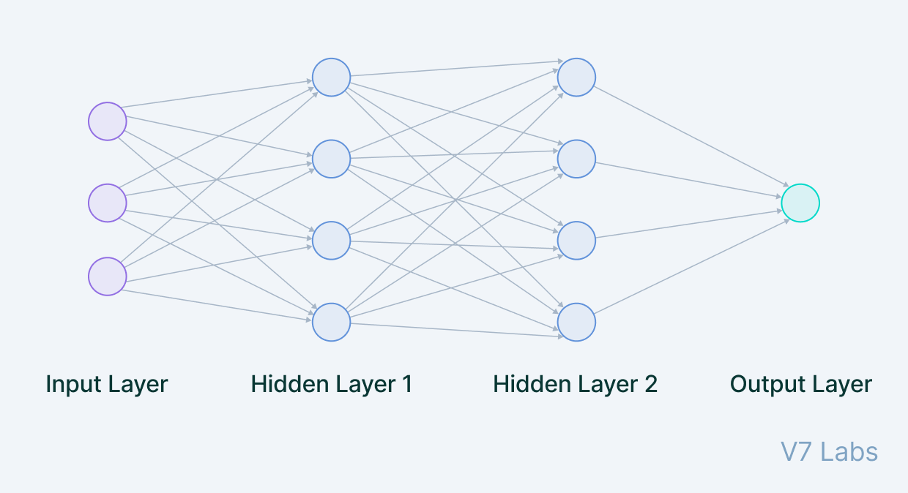

channels

channels

output

neuron

neuron

neuron

neuron

neuron

neuron

neuron

neuron

neuron

neuron

neuron

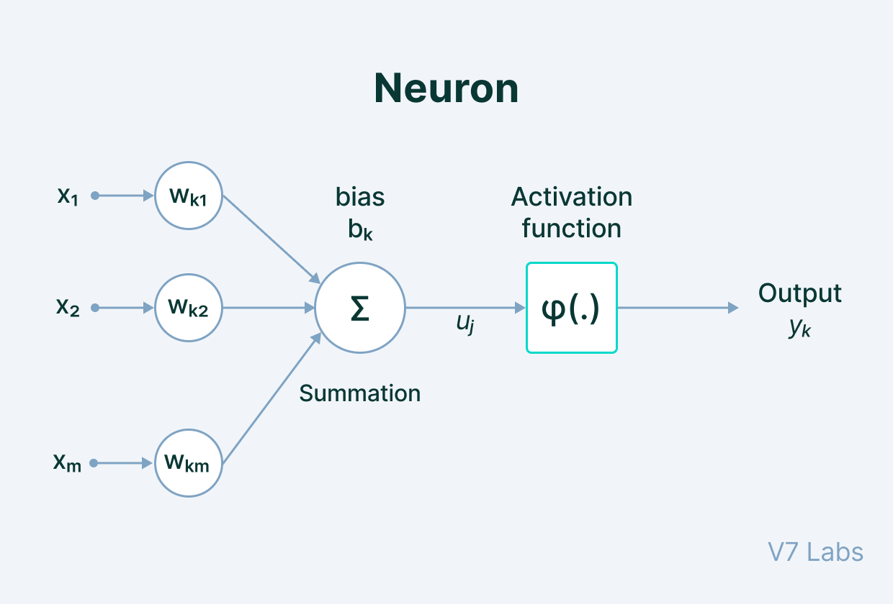



weightage

Features

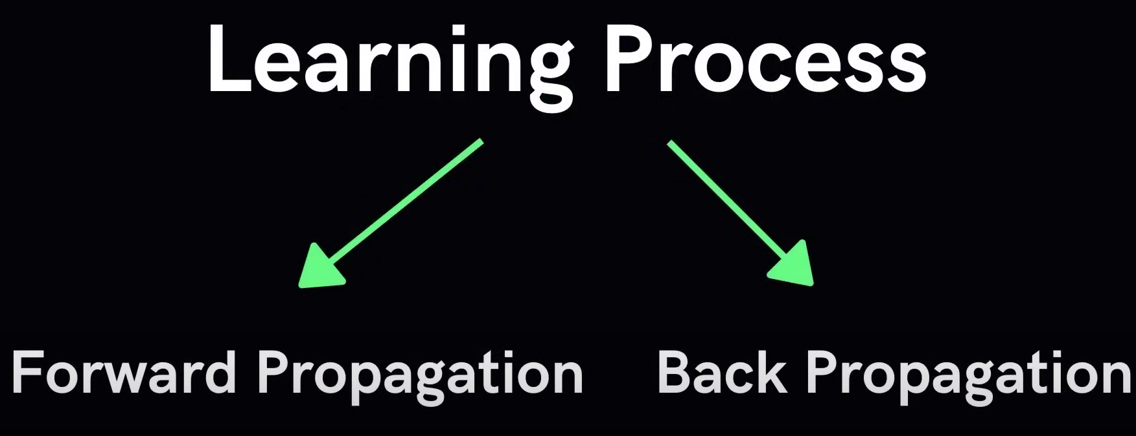

Like Forword propagation but in reverse direction. **Information from output to hidden layers [not input] {GRADIAN DECENT}**

Input to output layer

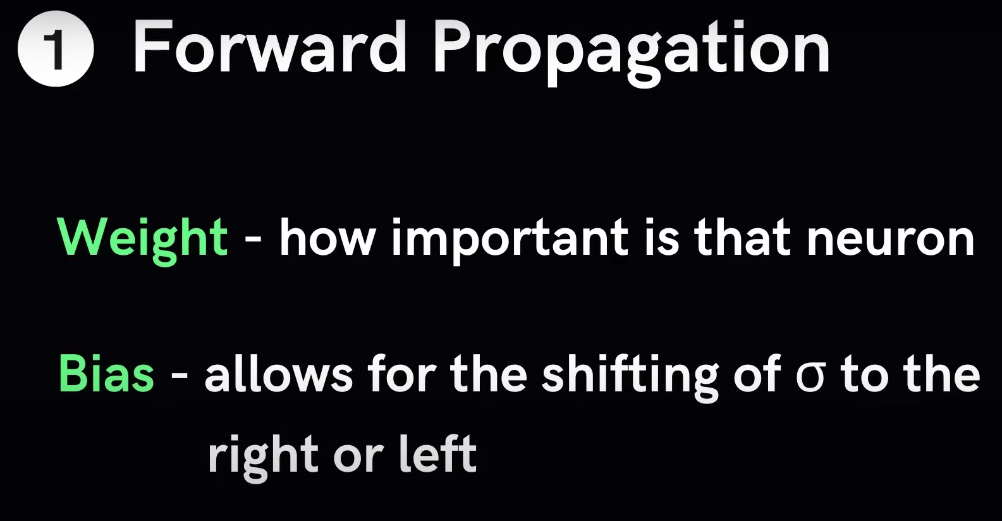

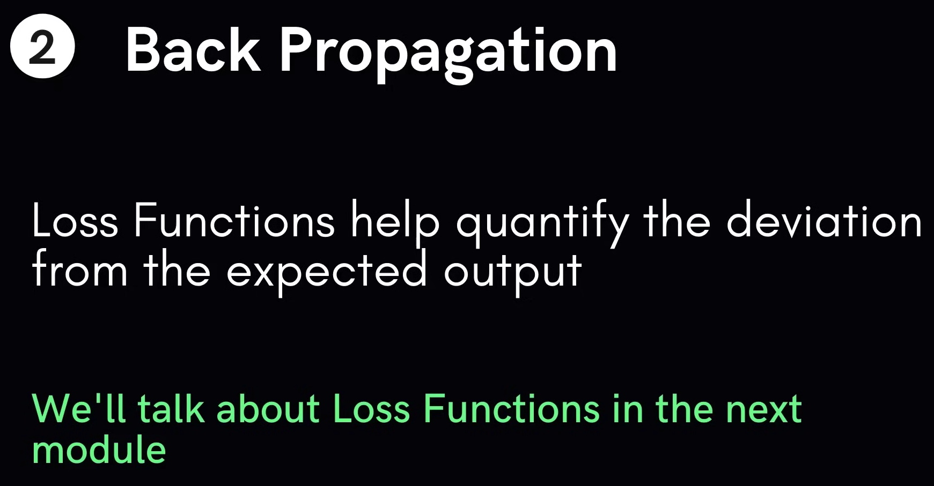

**Learning Algorithm**

1. Initialize Parameters with random values
2. Feed input data to network
3. Compare predicted value with expected value & calculate loss
4. Perform Backpropagation to propagate this loss back through the network
5. Update Parameters based on the loss
6. Iterate previous steps till loss is minimized

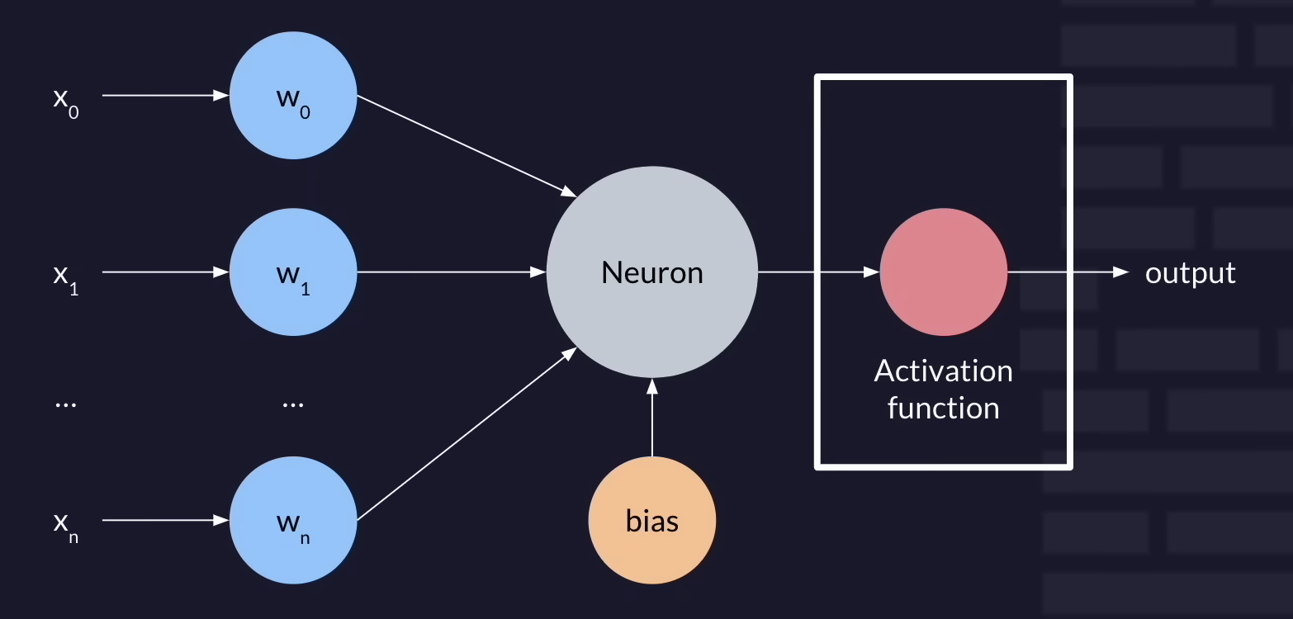

Without activation function it becomes Linear function

Non linear

Without activation function it becomes LINEAR model

# Activation Function

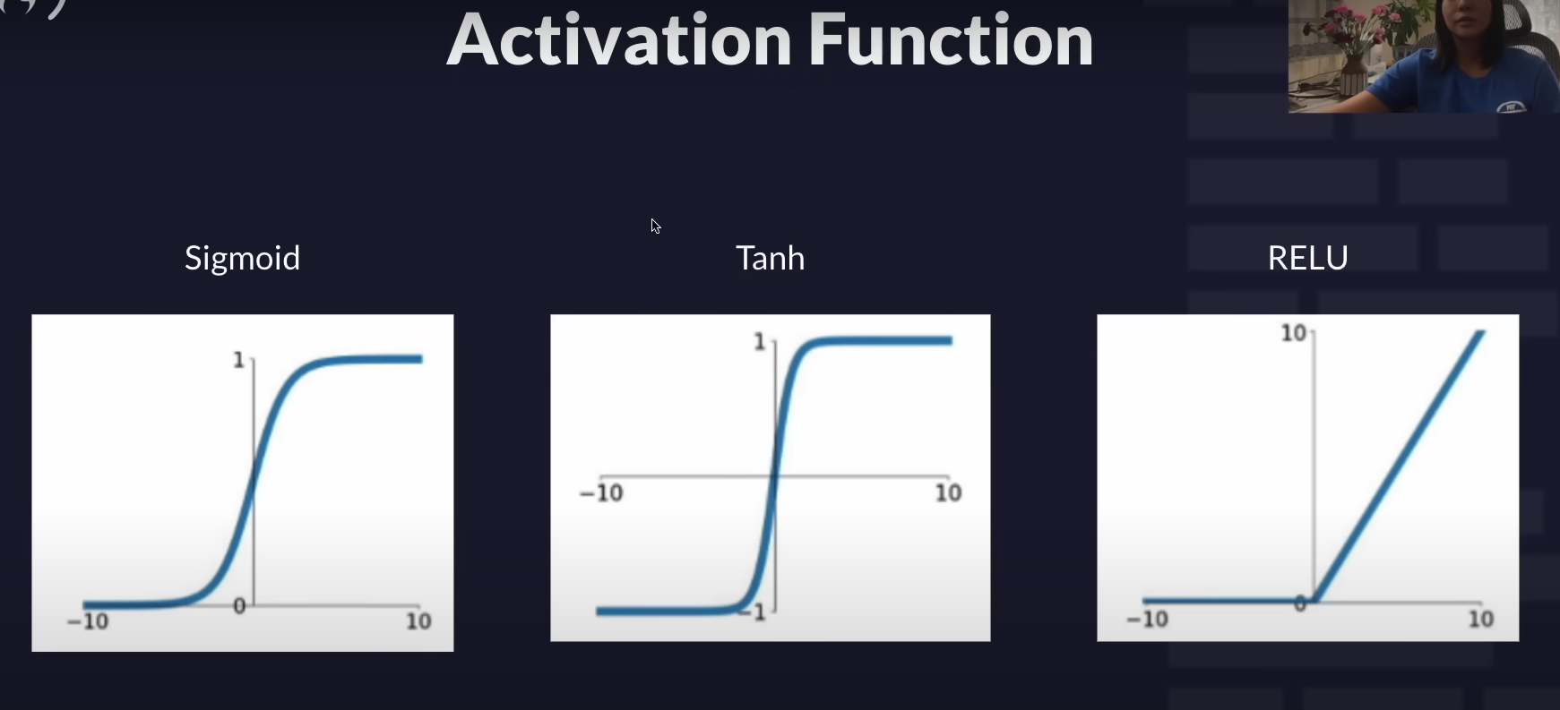

# Adjustments / Loss / Training

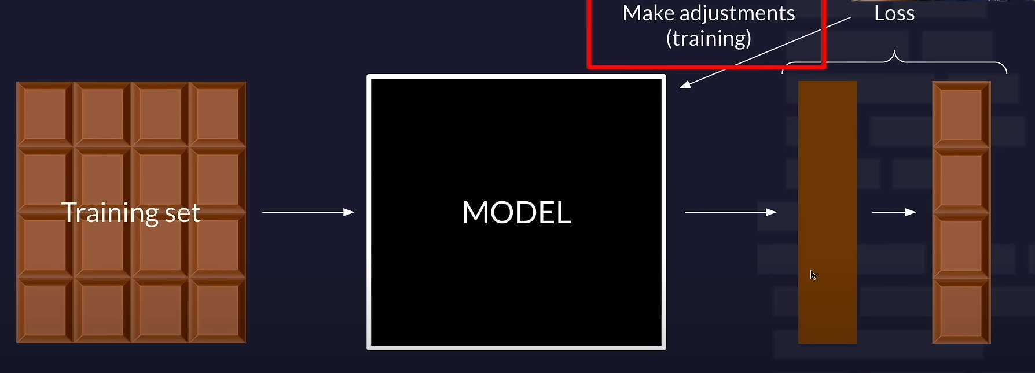

# Backpropagation

# L2 loss

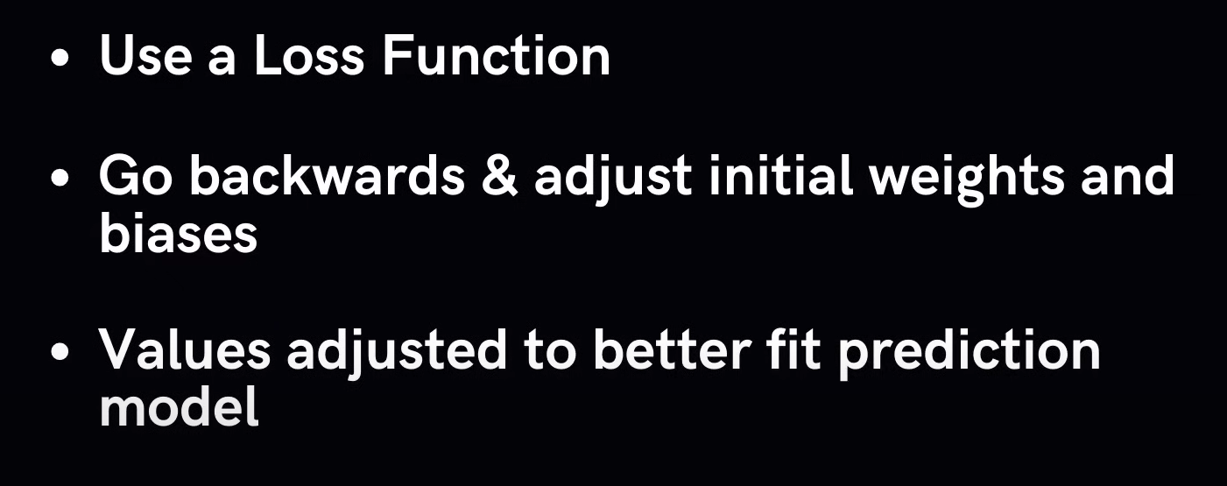

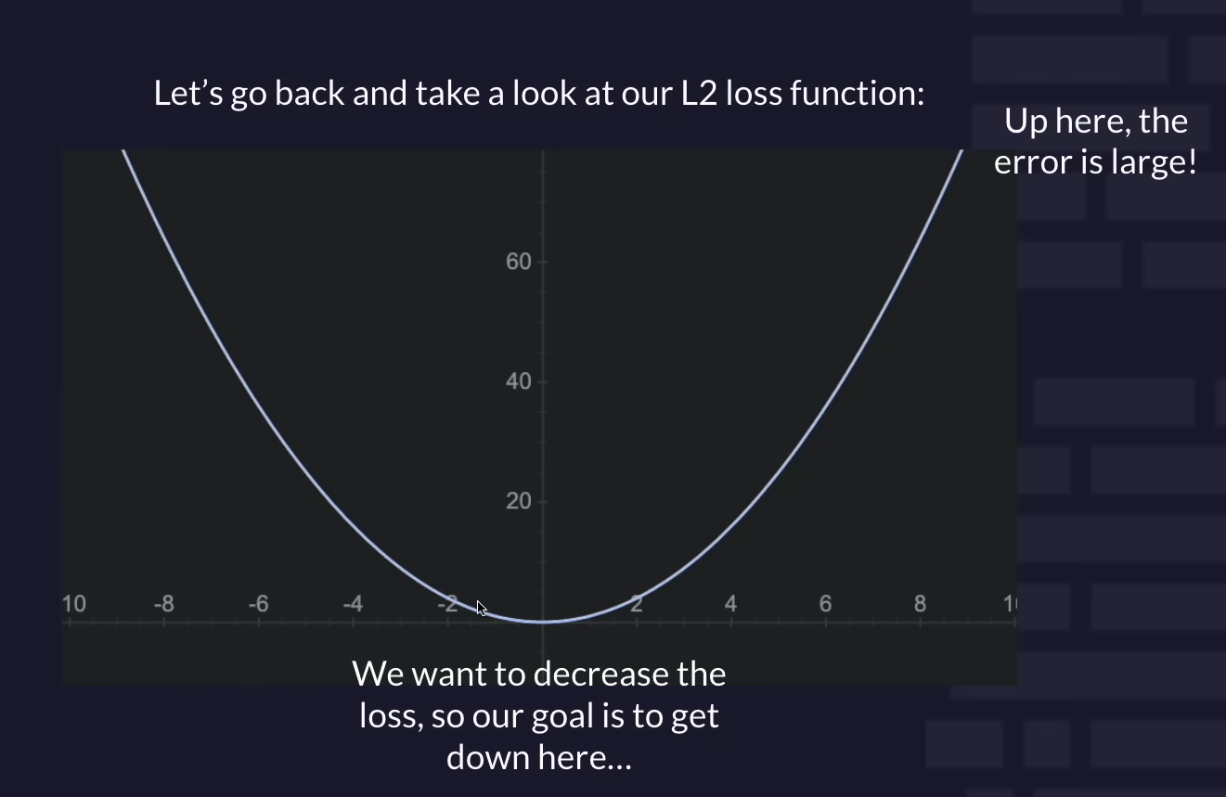

GRADIENT DESCENT

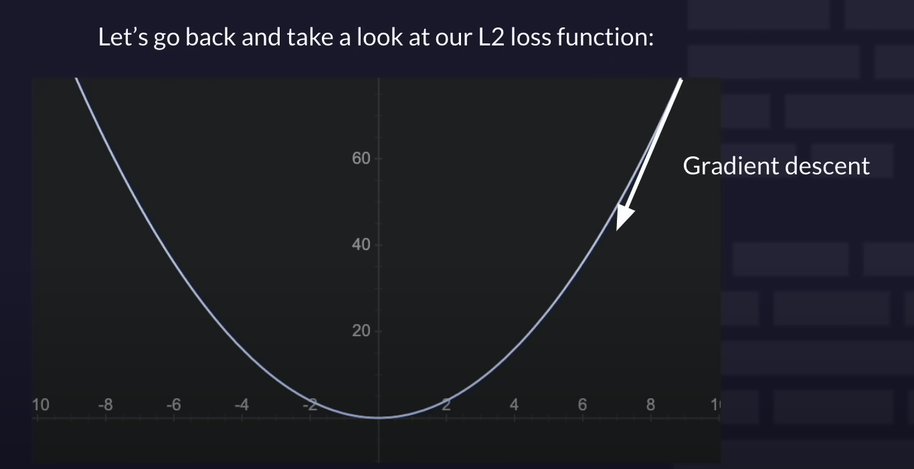

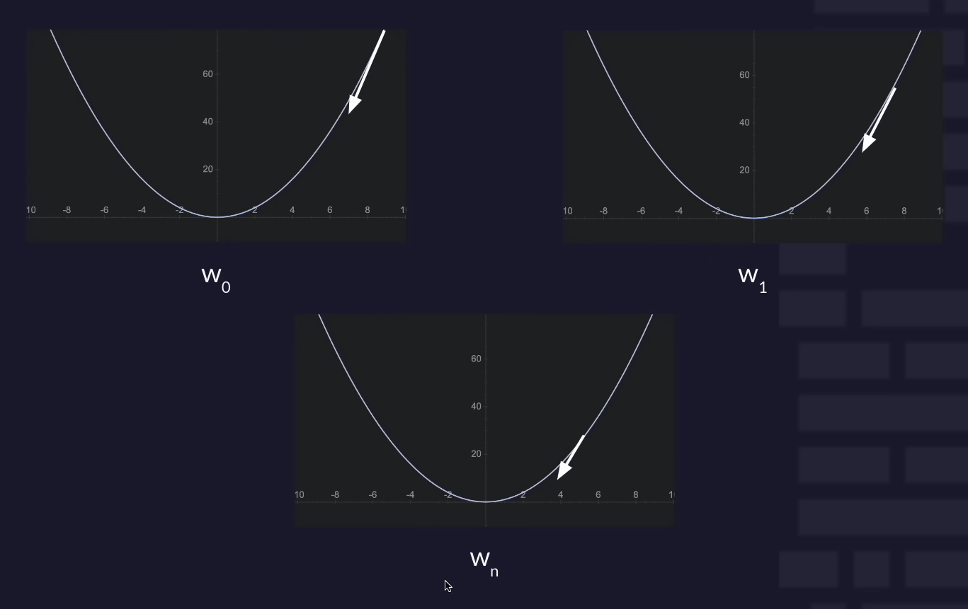

W= weightage

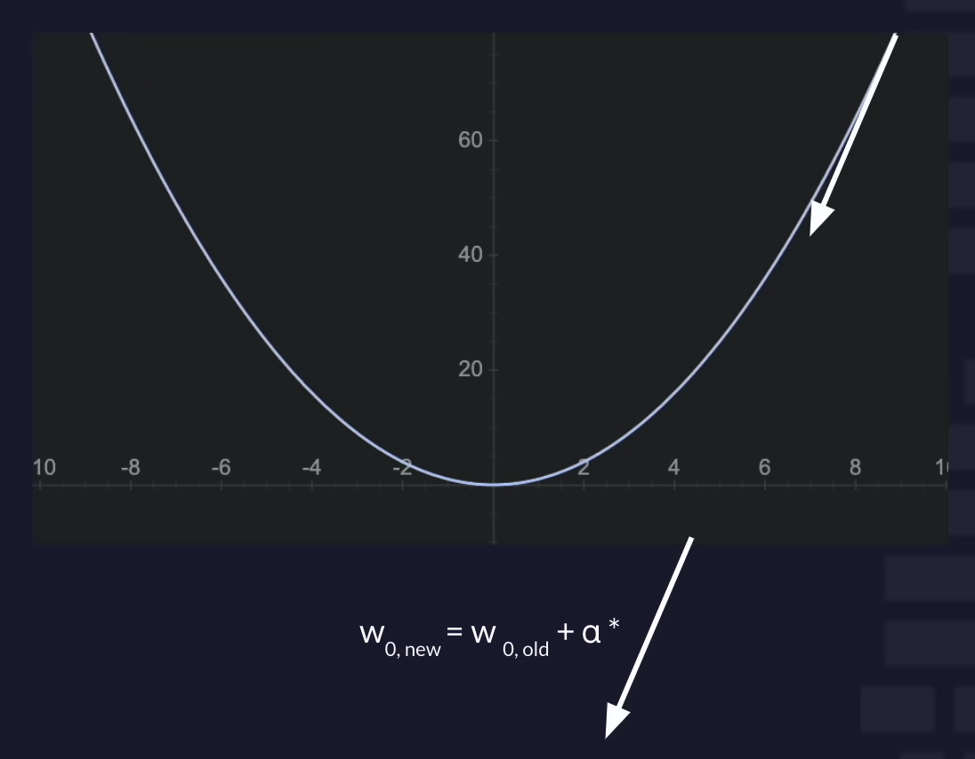

Learning Rate